**Project on Sales Forecast**

1. Company wise Analysis

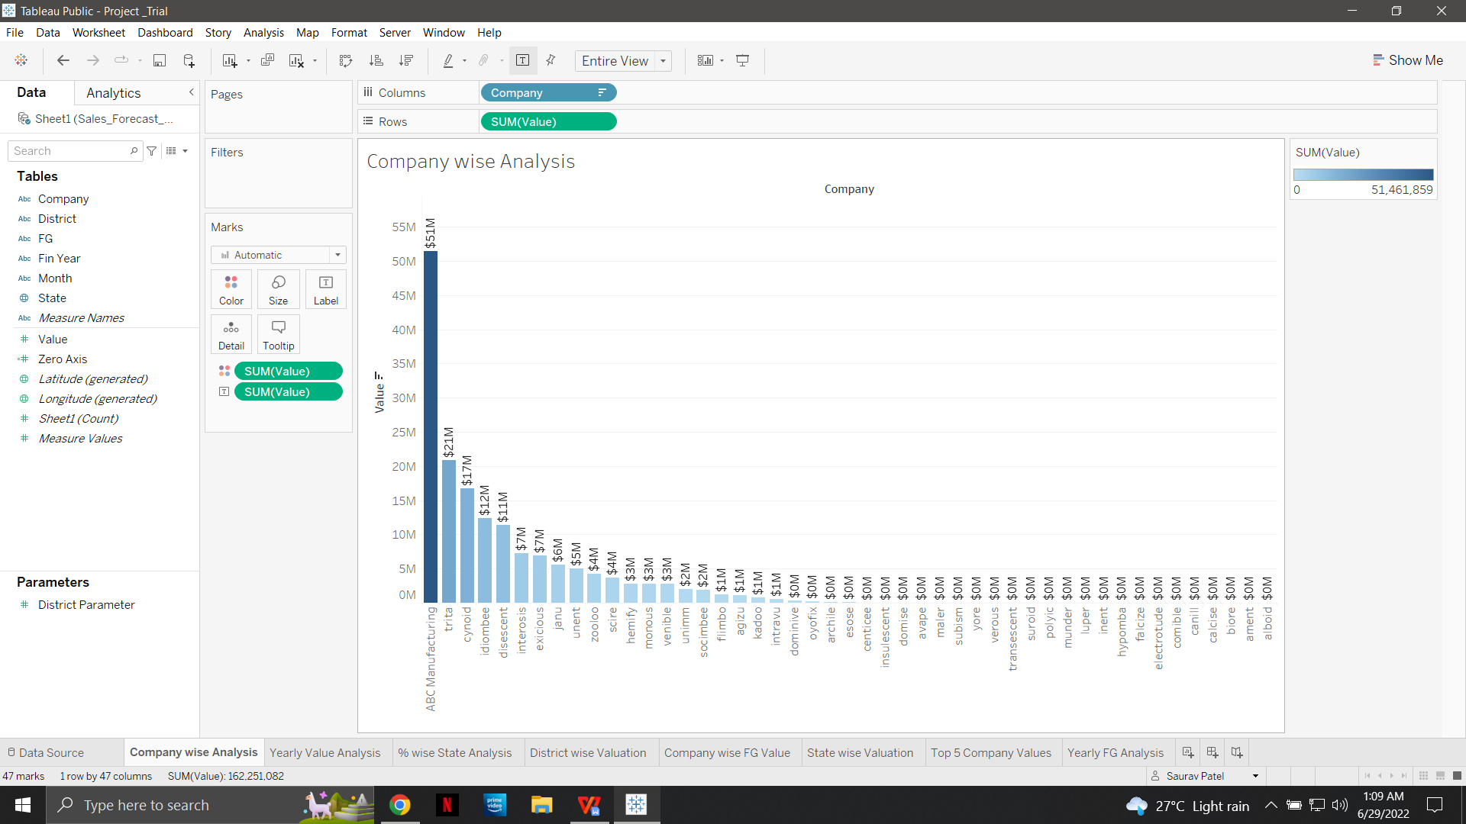

1. Yearly Value Analysis

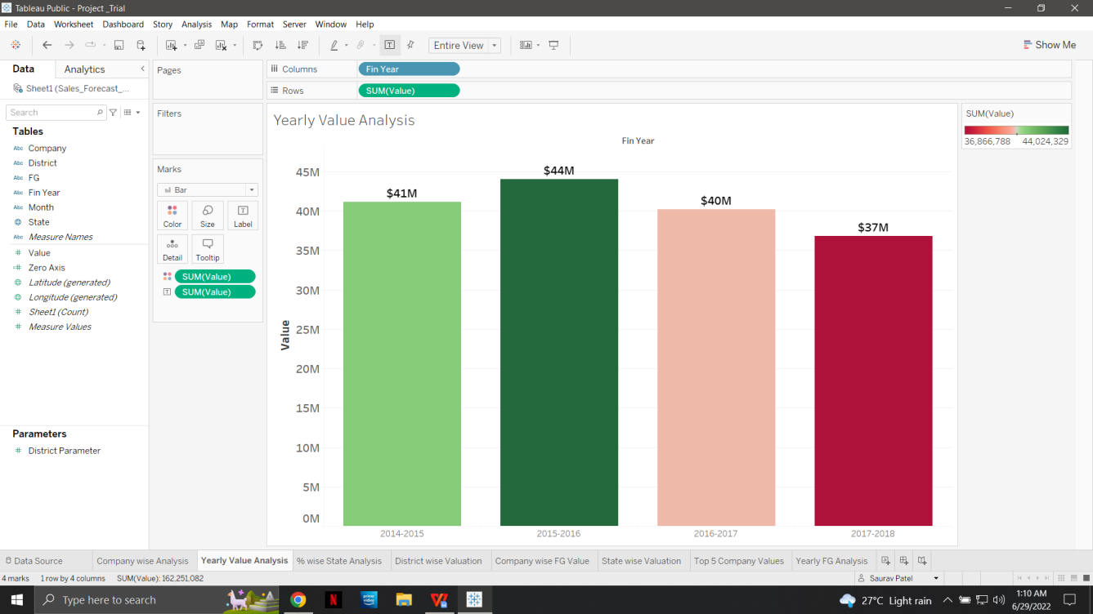

1. % wise State Analysis

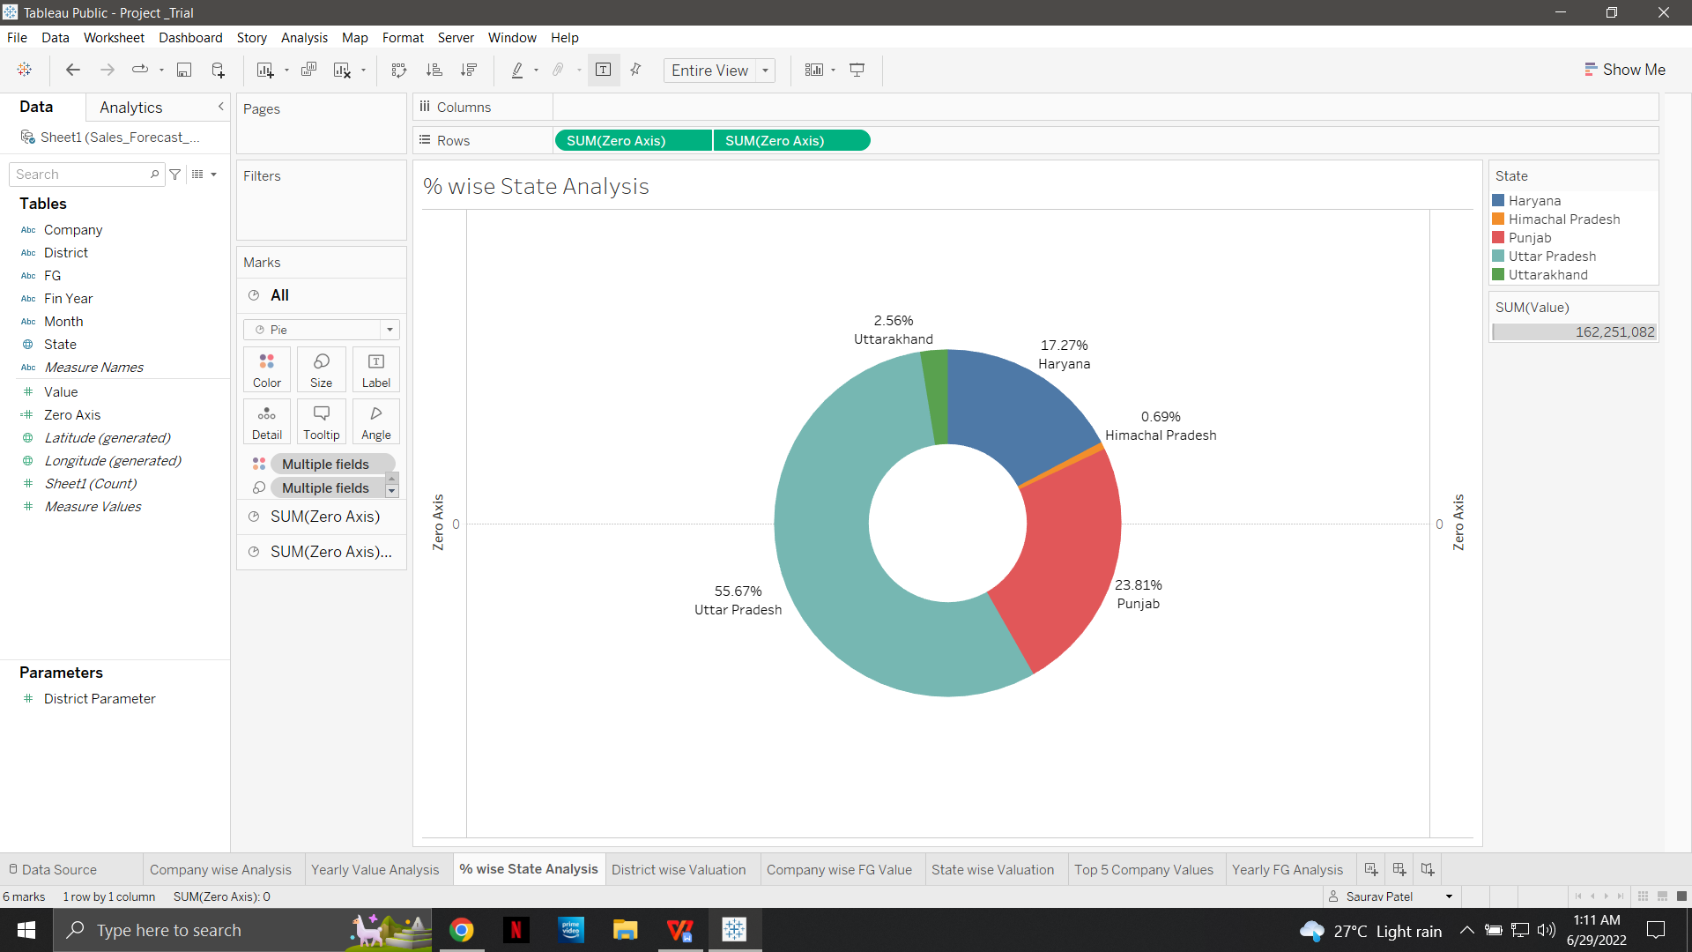

1. Dynamic District wise Analysis(Using Parameter)

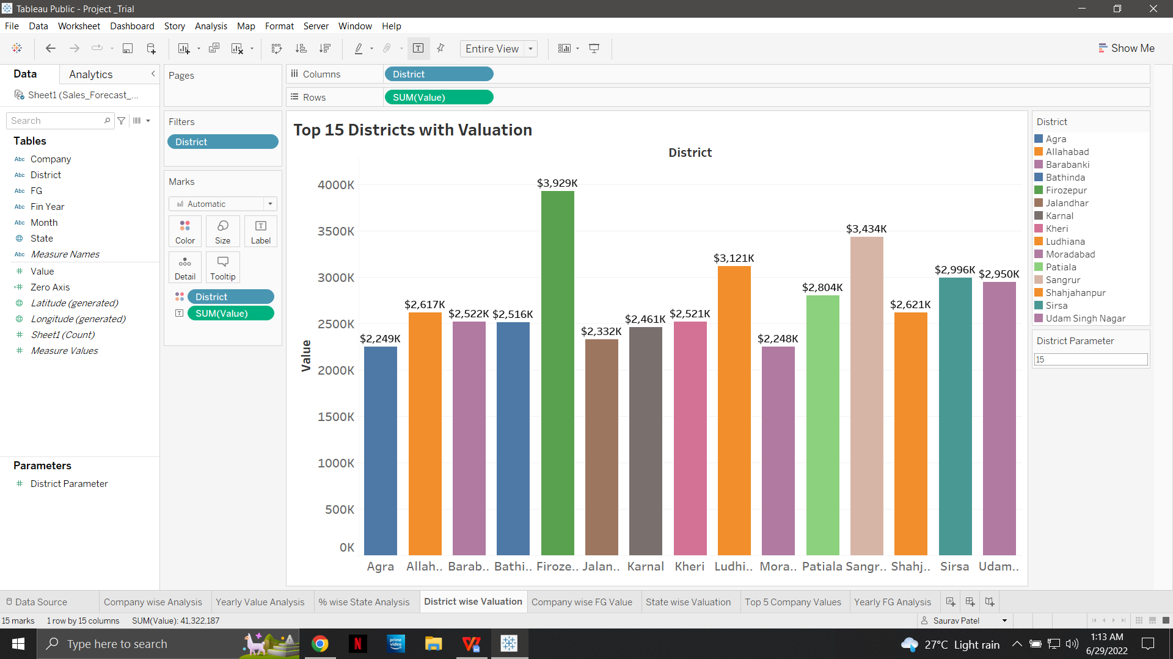

5. State wise Analysis(Map)

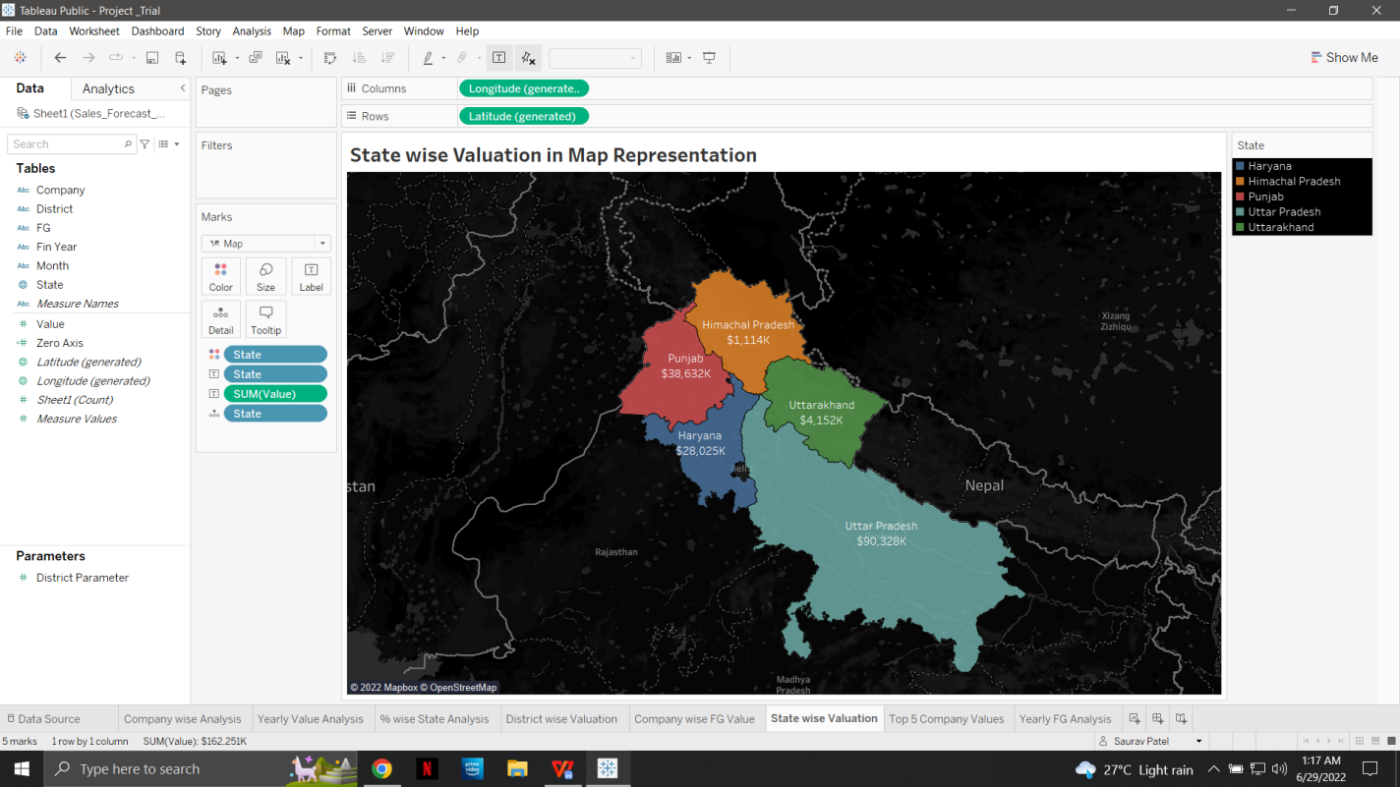

6.Top Five Company Analysis(Filter)

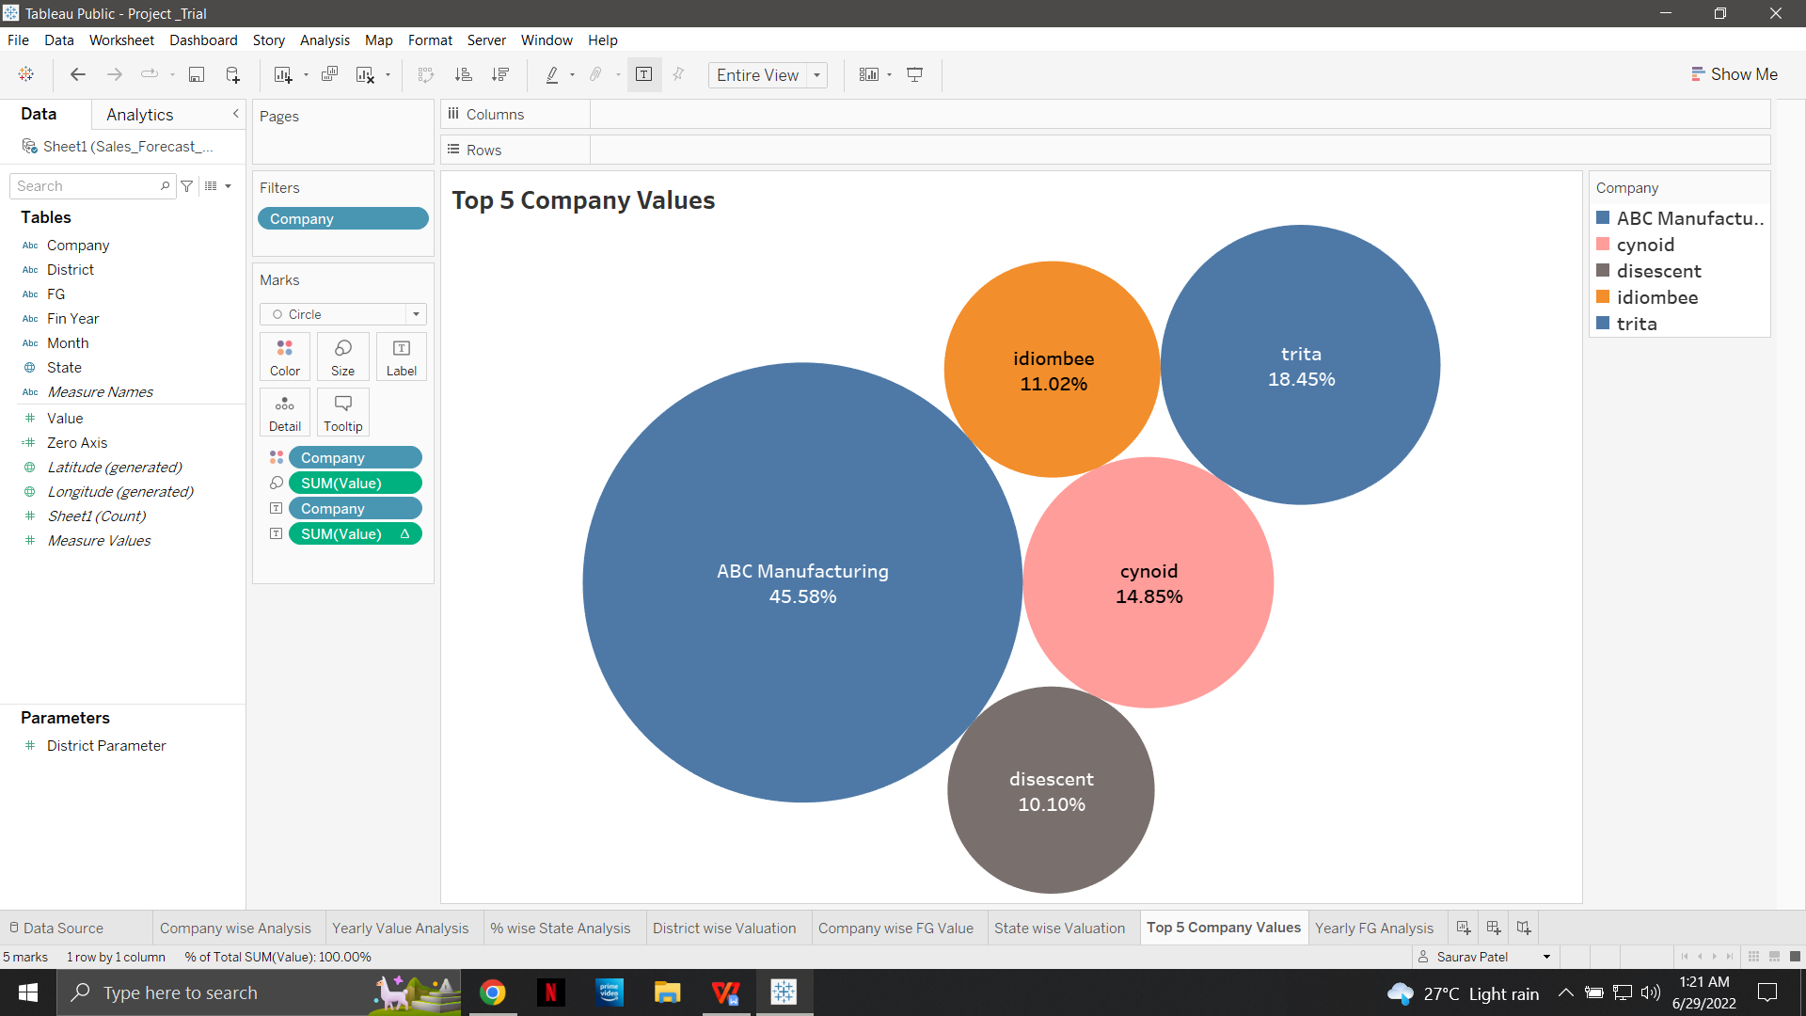

1. Yearly FG Analysis

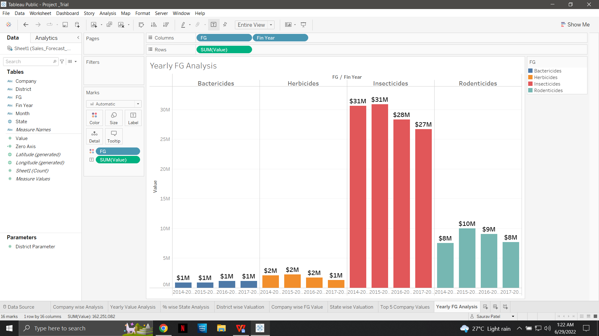

1. Company wise FG Value

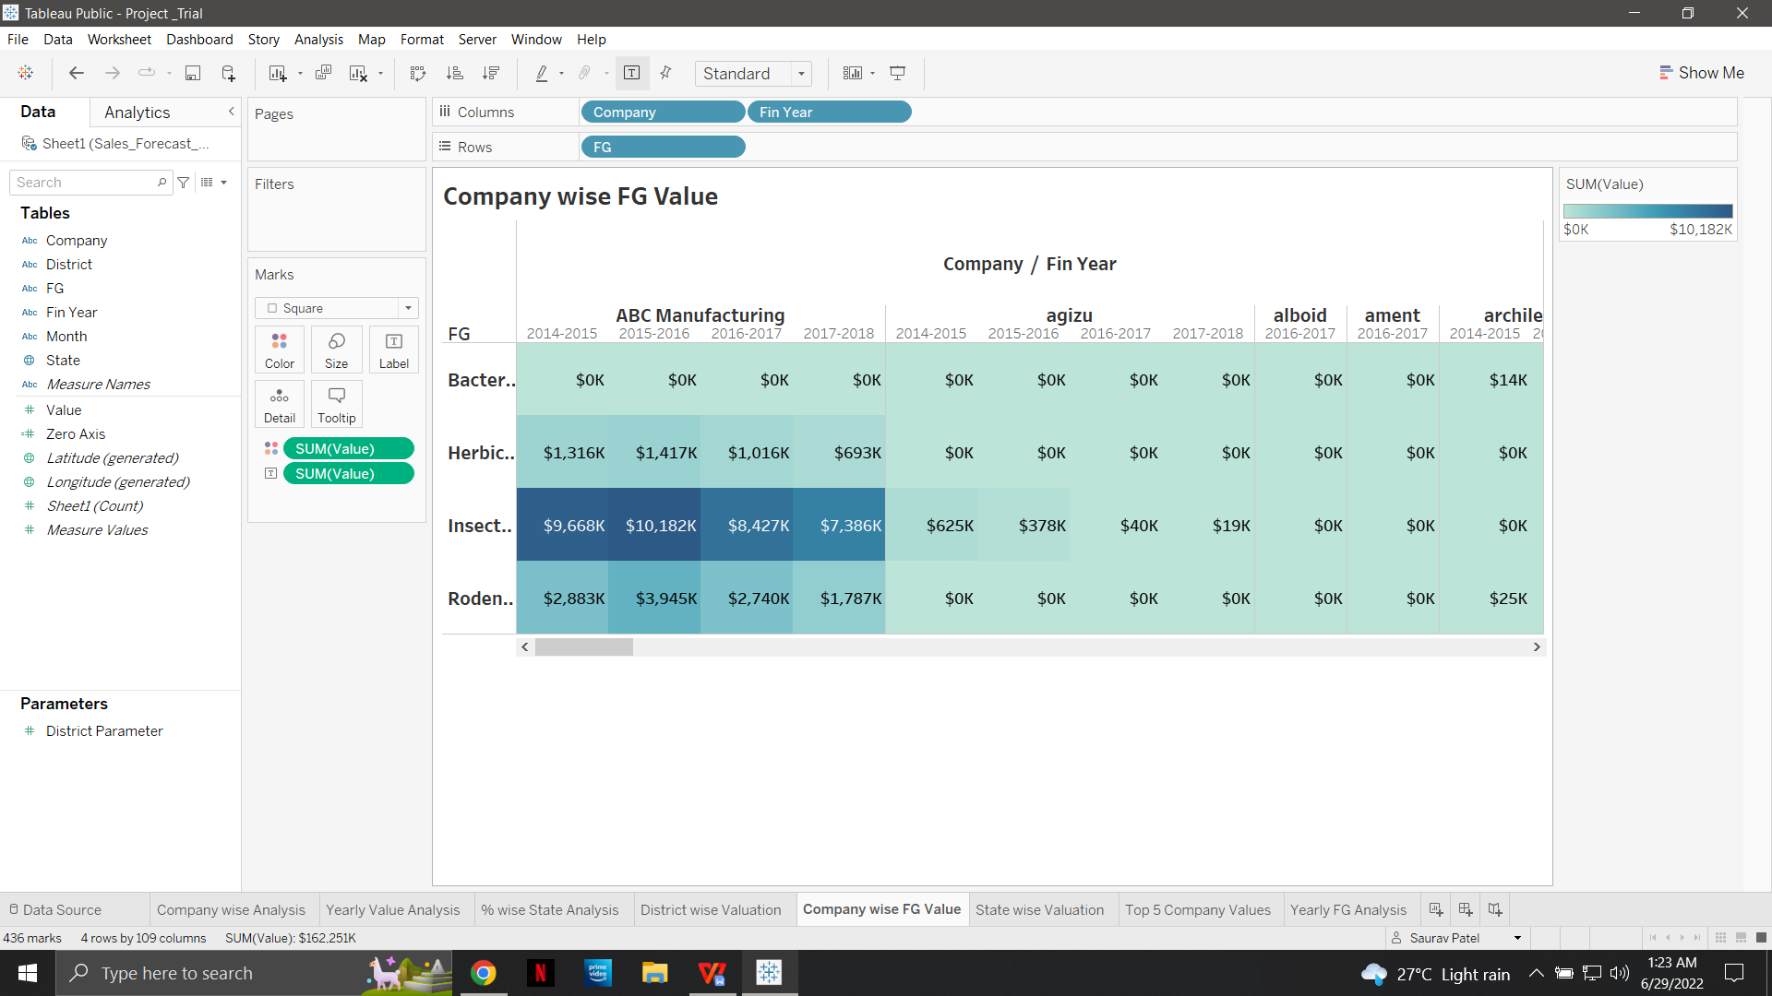

**Dashboard**

